**Autonomous Carrier Assistant (A.C.A)**

**A motorized platform to follow the user with collision detection**



**Department of Electrical Engineering & Computer Science**

**University of Central Florida**

***Group 5***

**Amine Chahli Electrical Engineering**

**Hunter Busa Computer Engineering**

**Muhammad Khan Electrical Engineering**

**Richard Garces Electrical Engineering**

**1. Project narrative description:**

**As technology advance, our way of living is changing too. Technology makes our life easier and simpler, change in the way a product or service is produced or delivered by reducing the resource the energy and the time. One of the modern innovations that researches and engineering working on is autonomous robots. Autonomous navigation must be a subject to many companies that are interesting in mobile robotics over the last decades. Following robots can have many applications in military, civil, or in at home. There is much application where the robot must localize the person and avoid obstacles such as shopping cart, luggage carrying, the robot in the hospital that help the nurse to carry the heavy products.**

**Autonomous navigation means that vehicle is self-driving without human intervention and that can plan its path and execute it. this autonomous cart or robot which can not only maintain its stability as it is moving, but it also can plan its next move. The motivation of this project comes from the hard time that we all face at the airport by pushing or pulling two 50-pound luggage from the entrance of the airport to the terminal. For young people that is a good exercise but if your old or in the rush and you can’t carry on or push your heavy suitcase. Also, think if you can’t speak English and you are in one of the biggest airports in the world and you don’t know the direction to your terminal in this case you can use this robot and u can type the terminal number and he will show the direction. Our idea is to build autonomous navigation that can follow the user or user can follow the autonomous vehicle.**

**The goal is to help the user to carry heavy boxes, tools, backpack, and luggage. For example, people that always carrying a heavy backpack to work every day this robot autonomous assistance carrier will be a great help for them. the robot will carry their backpack to the correct destination with any problems and in a short time without buying late to work.**

**The first objective is to help the user to carry his stuff. The second objective is to follow the user to his or her destination. The third objective is to help the user to find the direction by just entering the correct address on the app and after this the user needs to follow the robot to the destination. In this project, we are going to use an ultrasonic sensor to track the position of the signals and to avoid collision with other objects and to avoid obstacles during the driving, and this will be one of the main priorities and it is to avoid collision during the following up in a crowded environment. so the cart will maintain a decent speed, and distance. Also to avoid the objects, tracking the device by following the person’s direction, carrying the stuff, and giving the correct direction to the user.**

**3. The Requirements and specification:**

|  |  |  |
| --- | --- | --- |
| **Specification** | **Requirement** | **Target** |
| **Detecting the consumer** | **Use a camera to identify with a certain distance and follow consumers.** | **5 – 10 ft** |
| **Follow the consumer** | **Follow at a distance. Will also use GPS to follow via app on consumers phone.** | **2-4 ft** |
| **Lead the consumer** | **Will plan a route based on a map system and lead the consumer to their target destination at a distance** | **2-4 ft** |
| **Battery power** | **Will require a lithium-Ion battery or a Lithium-polymer battery. ACA will operate and needs to be recharged.** | **4 hrs battery life** |
| **Move with weight** | **Motors will be able to move an item up to 50lbs in weight at a steady speed.** | **2-3 mph** |
| **Connect to application via Bluetooth** | **The ACA will connect with the application on a smart phone and be able to do all function associated with the app within certain time.** | **20-30 sec** |
| **Recharging ability** | **Will be rechargeable. Have a mode in which it can get itself to a charging station when battery is below 10%. When not in use.** | **1-2 hrs** |

**4. Block diagram:**

|  |
| --- |
| **Color** |
| **Hunter Busa** |
| **Muhammad Khan** |
| **Amine chahli** |
| **Richard Garces** |

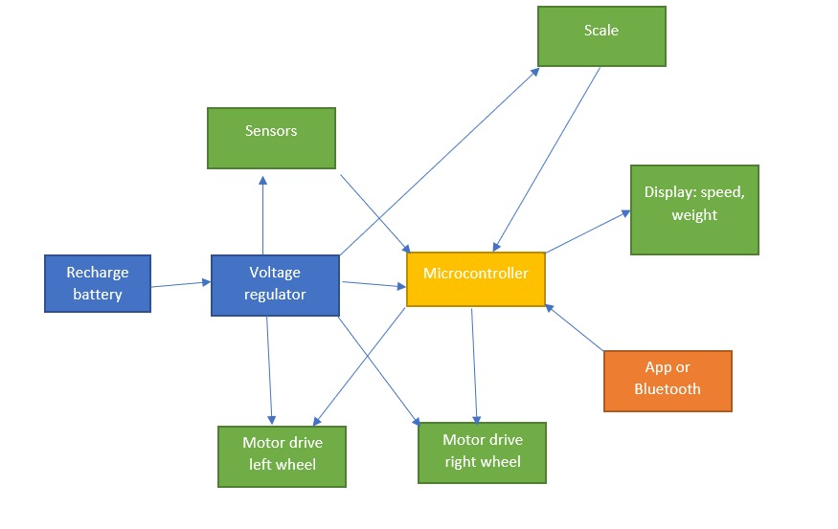

**Software Block Diagram**

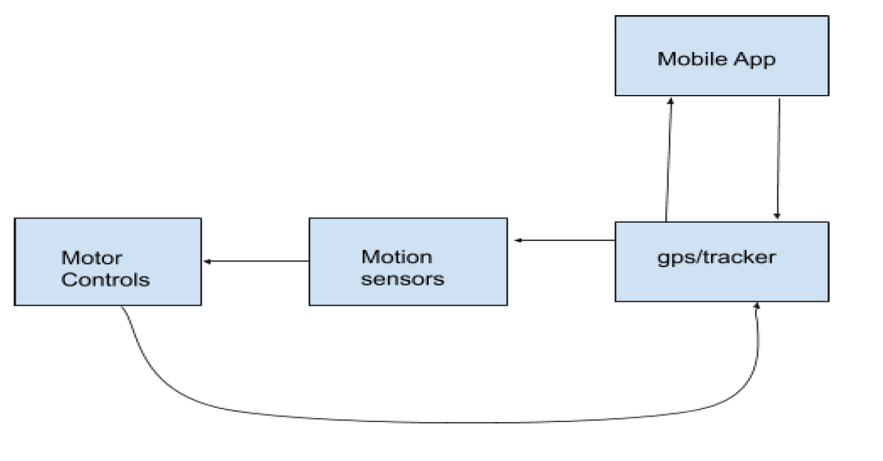

**Mobile App Block**

**Status: Research**

**Input: The User will give commands to the bot such as Follow, Lead, Charge.**

**Output: Connects to the GPS block using Bluetooth and gives data on what to do.**

**Owner: Hunter Busa**

**Details: The app will most likely be coded in Java or javascript.**

**Gps/tracker Block**

**Status: Research**

**Input: Data that is coming from the Mobile App block which tells where the GPS where the phone is located. Also, information coming from the Motor Control block updating which direction the bot is moving.**

**Output: Current location to the Mobile App and Motion sensors block.**

**Owner: To be determined**

**Details: The app and the GPS will be connected together using Bluetooth.**

**Motion sensors Block**

**Status: Research**

**Input: Receives the current location of the bot from the GPS block and information on potential threats around the bot that is being picked up by the sensors.**

**Output: Will give out warnings to the Motor controls block about threats around the bot and also will give suggestions on alternate routes to take.**

**Owner: To be determined**

**Motor Controls Block**

**Status: Research**

**Input: Receives information from the Motion sensors block that warns the motor controls to turn because of an object in the way.**

**Output: Controls the speed of the wheels and what direction the bot will go in. Also updates the GPS block of what direction and how fast the bot is moving.**

**Owner:** Muhammad Khan

**Display Block**

**Status: Research.**

**Input: the voltage regulator will be connected to the display for power. the microcontroller will be also connected to display.**

**Output: the output will be the batter level and the weight of the luggage.**

**Details: the display will get power from the voltage regulator and the information from the microcontroller.**

**Owner:**

**Motors Block**

**Status: research.**

**Input: is the power coming from the voltage regulator and speed from the microcontroller.**

**Output: is the velocity of the wheels for both motors lift and the right one.**

**Detail: the voltage regulator gives the power to the motors and regulator controlling the speed.**

**Scale Block**

**Status: research**

**Input: the input for scale is coming from the voltage regulator**

**Output: is the weight of the luggage or the data**

**5. The project budget and cost:**

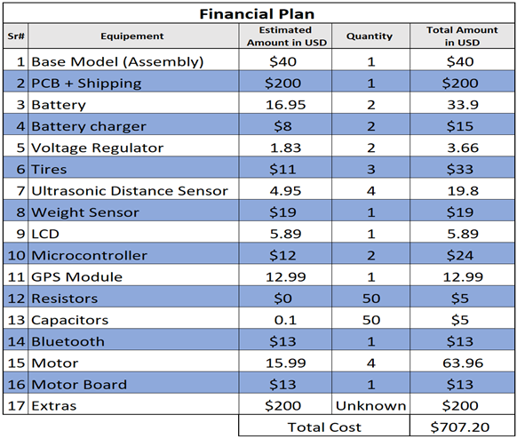

**As per our financial plan given above in the table, we should end up spending below 700 USD for this project. We don’t have any sponsors for this project so far; therefore, this amount will be divided equally into four of us in order to implement this design. We will keep 200 USD for extra expenses in addition to the 700 USD budget in case we need to add more components for this design. We will try to cut down this amount by 20-30% by negotiation with the vendors or trying to find the replacement for some items with its alternate which has the same features but low cost. Our financial policies are clear for this project to reduce the estimation amount and add one or two more features in our design if we will be able to keep the budget under control.**

**6. Initial project milestone**

**Goals for each month of both semesters.**

**January**

**Complete the Divide and Conquer assignment and decide on what our project will be.**

**February**

**Begin research of the project and also begin the senior design paper with at least 40 pages complete by the end of the month. Also start to price out all the equipment that we will need to make the project.**

**March**

**Complete at least 80 pages by the end of the month and begin the PCB design. Also start to purchase the equipment for the project.**

**April**

**Complete the final draft of the senior design paper that will be at least 120 pages long and also finalize the design for our project.**

**May**

**Begin construction of the project**

**June**

**Continue building the project and begin coding the mobile app that will control the project.**

**July**

**Start testing and implementing all the designs for the project and hopefully finish by the end of the month.**

**August**

**Present our project at the Senior Design showcase.**